Oracle BIP – Report Documentation

Document Title: Visa expiration report
Version: 1.0
Date: 15/01/2026
Prepared By: K Kishore
Reviewed By: Supriya Darisa

1. Business Object
Report should fetch the list of employees who has visa expiry between Run date -30 days to +90 days.

2. Data Model

2.1 Data Model Name / Path
visa_details_emplyoee

2.2 SQL / Data Set
SELECT
ppf.person_number,
pnf.first_name,
pnf.last_name,
ppf.start_date AS hire_date,

ph.phone_number AS home_phone_number,
pea.email_address AS personal_email,

paf.action_code,
paf.reason_code,

pj.name AS job_name,
pd.name AS department_name,

vpf.legislation_code,
vpf.visa_permit_number,
vpf.visa_permit_status,
vpf.issuing_country,
vpf.issuing_location,
vpf.issue_date,

NVL(vpf.entry_date, vpf.issue_date) AS entry_date,

vpf.expiration_date

FROM per_people_f ppf

JOIN per_person_names_f pnf
ON ppf.person_id = pnf.person_id
AND pnf.name_type = 'GLOBAL'
AND TRUNC(SYSDATE) BETWEEN pnf.effective_start_date
AND pnf.effective_end_date

JOIN per_assignments_f paf
ON ppf.person_id = paf.person_id
AND TRUNC(SYSDATE) BETWEEN paf.effective_start_date
AND paf.effective_end_date

LEFT JOIN per_jobs pj
ON paf.job_id = pj.job_id

LEFT JOIN per_departments pd
ON paf.organization_id = pd.organization_id

LEFT JOIN per_phones ph
ON ppf.person_id = ph.person_id
AND ph.phone_type = 'H1'

LEFT JOIN per_email_addresses pea
ON ppf.person_id = pea.person_id
AND pea.email_type = 'H1'

JOIN per_visas_permits_f vpf
ON ppf.person_id = vpf.person_id
AND TRUNC(SYSDATE) BETWEEN vpf.effective_start_date
AND vpf.effective_end_date

WHERE TRUNC(SYSDATE) BETWEEN ppf.effective_start_date
AND ppf.effective_end_date
AND (ppf.person_number = :P_PERSON_NUMBER OR :P_PERSON_NUMBER IS NULL)
AND (pd.name = :P_DEPARTMENT_NAME OR :P_DEPARTMENT_NAME IS NULL)
AND (pj.name = :P_JOB_NAME OR :P_JOB_NAME IS NULL)

2.3 Parameters (If Any)
Parameter: P_PERSON_NUMBER, P_DEPARTMENT_NAME, P_JOB_NAME

3. Report

3.1 Report Name / Path
visa_expiration_report

3.2 Output Format(s)
☐ Excel ☐ CSV ☐ XML ☐ PDF ☐ Other: Excel

3.3 Schedule (If Applicable)
☐ Not Scheduled ☐ Scheduled – Frequency: Not Scheduled

4. Template (Optional)

4.1 Template Type
☐ RTF ☐ None (Raw Data Output)

4.2 Template Description
Report must fetch following fields into the report
Person Number
First Name
Last Name
Hire Date
Home Phone Number
Personal Email address
Action Code
Reason Code
Job Name
Department Name
Legislation Code
Visa Number
Issuing Country
Visa Status
Place of Issue
Issue Date
Entry Date
Expirattion Date

5. Sample Output (Optional)

5.1

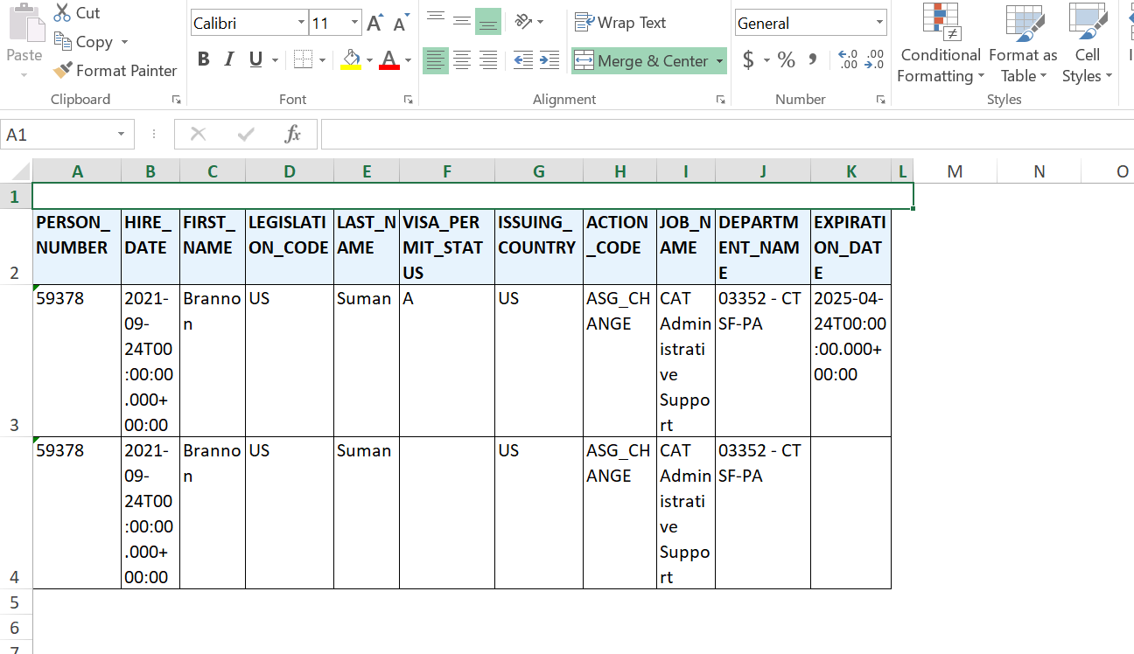
Output – Excel Template

5.2
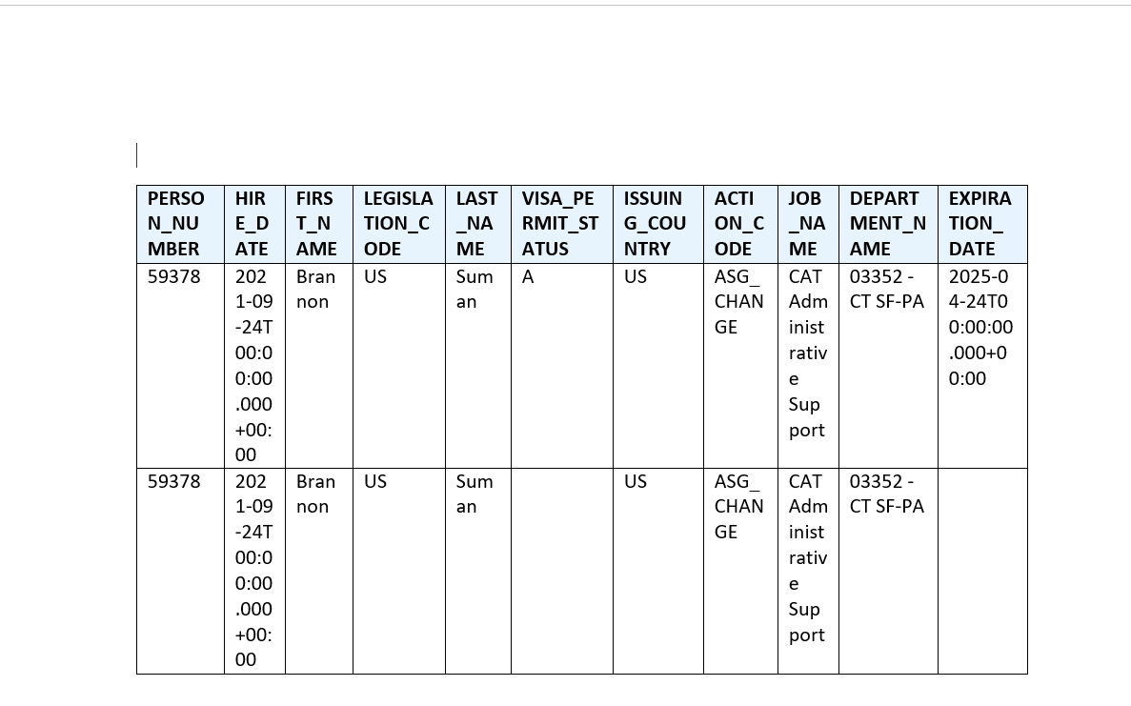
Output – RTF Template

6. Test Cases
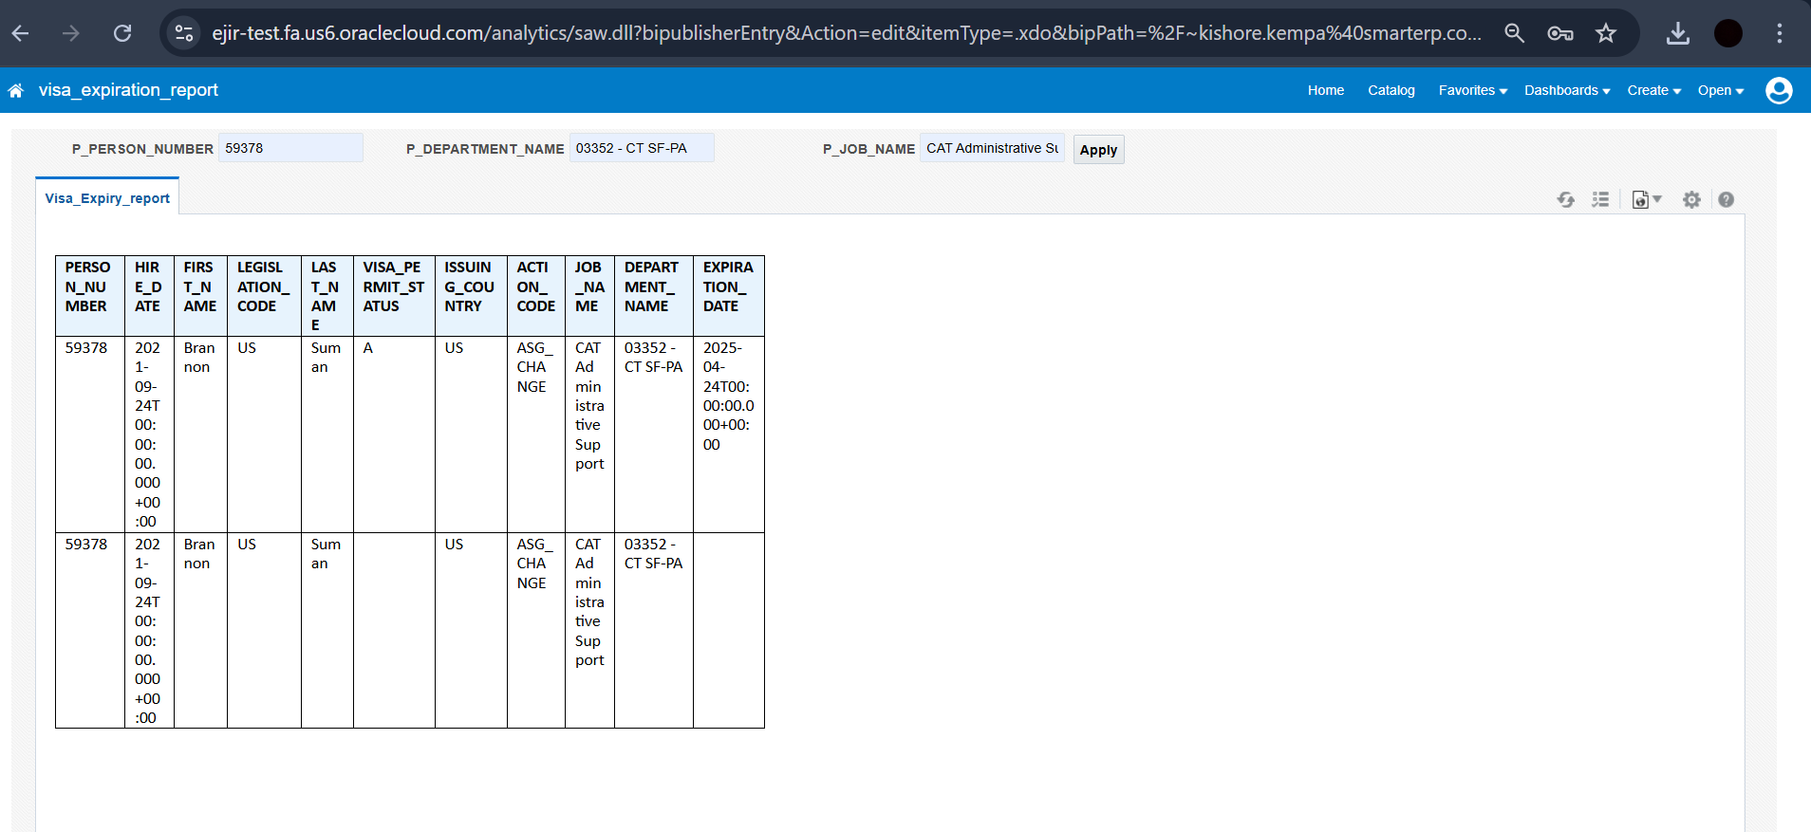

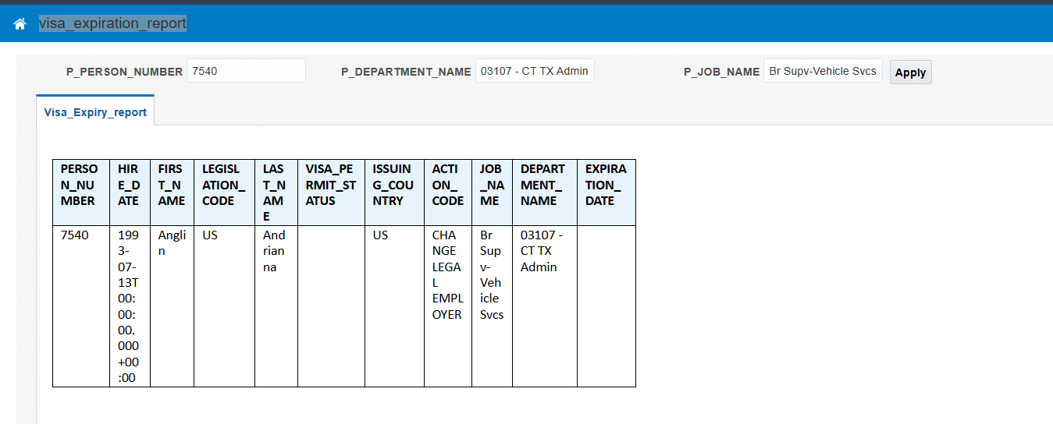
Output with the different parameters

After :
AND vpf.expiration_date BETWEEN TRUNC(SYSDATE) - 30
AND TRUNC(SYSDATE) + 90
